Mohamad Maarouf
CSC400
Rough Draft: Documentation
2/24/19

Introduction

The new system that I am creating is a Fitness Diary. The fitness diary will have a few key features including the ability to post a diary of your workout, the power move you are working on, the date you lifted, and how much you lifted for that day. There will also be a graph button which when clicked, will generate a graph of how your weight lifts are increasing week by week. You will also have a profile page where you can write about yourself, what gym you go to, set a workout goal from a choice of three power moves (bench press, squat, and deadlift) and how much you want to improve on those lifts. You will also have the ability to view other people’s profiles. There will be a dashboard to help you maneuver through the website. There will also be a button on the dashboard to take you to a page where there will be accredited articles on the three power moves and how to improve them. Many apps are used to be able to track your progress in a certain lift such as the bench press. In these apps, you can choose the workout and how much you lifted for a specific day. These apps, however, lack the ability for you to have a section where you can talk about the workout. Basically, the fitness diary allows you to not only come up with a goal and track your progress for a specific power move, but to also write about your day and in this way you can keep track of what works and what doesn’t work. Many apps do not have a graphing section where you can see your progress in a physical graph. Also, you get to have a profile page and there is a social aspect where you can view other people’s profiles. The potential users of this app will be power lifters or anyone who wants to work on the three power moves (squat, deadlift, and bench press) and to set a goal, track their strength, track their mood, write down their thoughts about the workout, have a set diet plan that they can follow, and who want to view other people’s profile and learn about how they are doing their workouts. Also, it will serve as a one stop guide for them where they can see accredited articles on the power moves and come to read up and research.

Architecture
Fitness Diary will be a web application created using flask and python. It will be written on vscode and will run on the google cloud. Everything will be in the form of a website, from the landing page, login page registration page, profile page, diary page, dashboard, and the articles page. It will be styled using html, and will have python and flask running on the backend. I will use SQL to hold all the information on login users, diary postings, and profile pages.

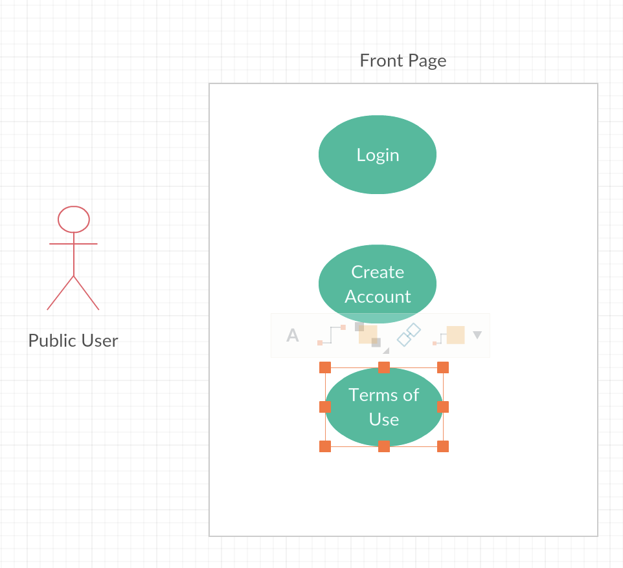

The first thing a user is faced this when accessing the website, are three main functions. The user has the ability to either login with an account that has already been created, or to create a new account, or to view the terms of use/help page, etc.

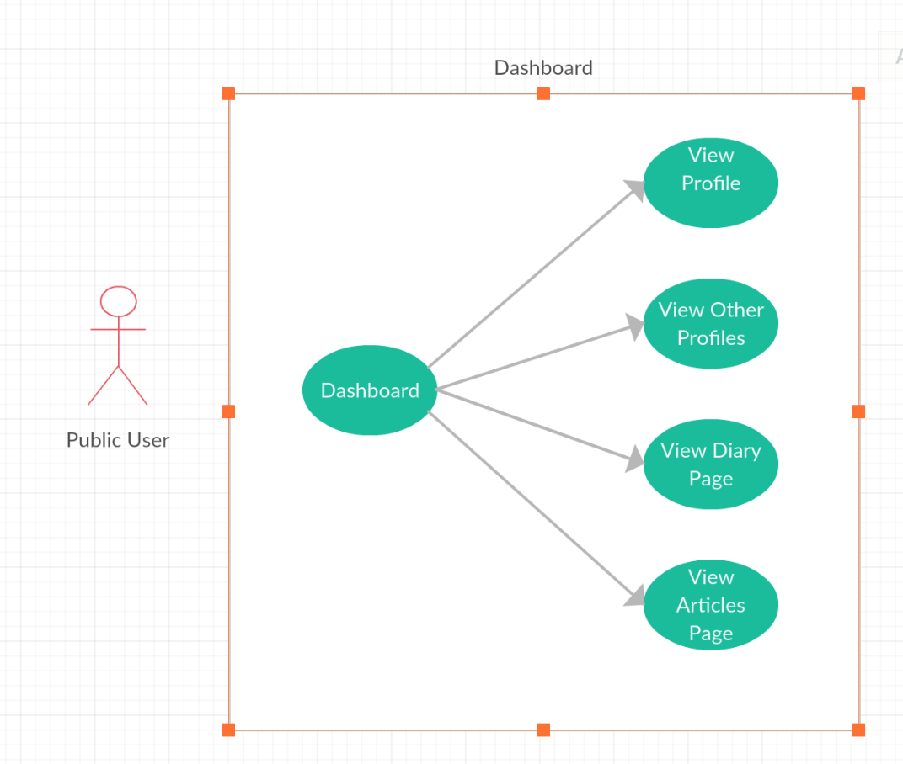
The public user, once logged in, has a dashboard from which they can navigate to other pages. The dashboard allows the user to navigate to his own profile, to a page where he can view other people’s profiles, to a page where he can view his fitness diary entries, and to a page with links to fitness articles that are manually updated by the admin. Each of these are a function which will lead to another page.

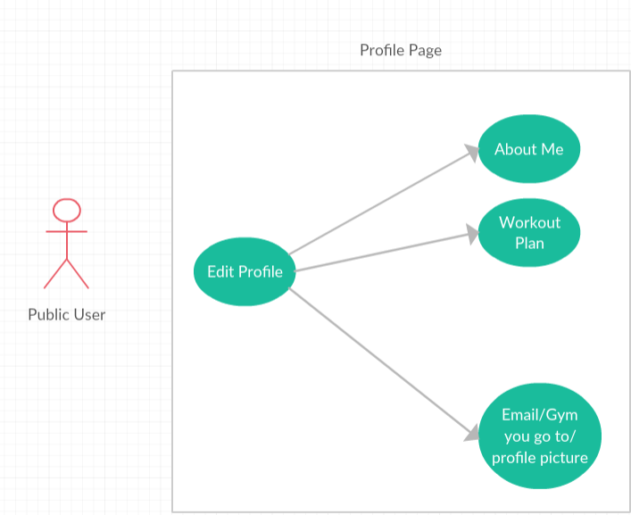
Once the user is on his profile page, he has an edit profile option where he can edit his profile. He will able to edit an about me section, a section where he can write down his/her workout plan, and edit simple sections like their email address, what gym they go to, and even post a profile picture. In the about me section, it will be an open text box for the user to talk about himself. In the workout tab, however, the user will have a text box where he can enter his goal of how much weight he wants to lift, but there will also be a drop down menu, where the user can choose to set whether he wants to work on the goal of either bench press, squat, or deadlift.
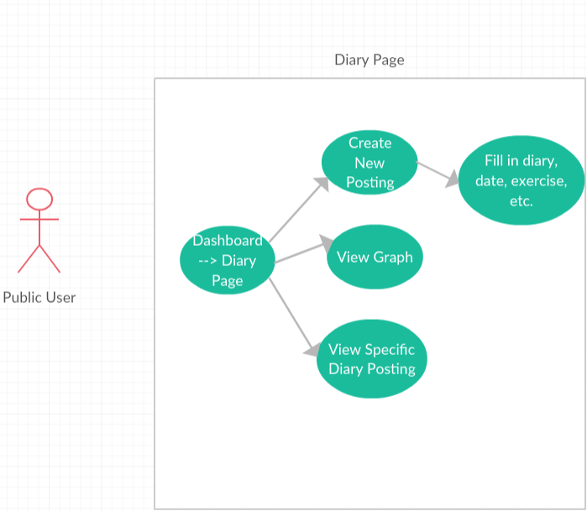
From the dashboard, the user can click on their Diary page. This is the page full of diary postings about their workout for that day, including whether they worked on bench press, squat, or deadlift, how the workout went that day, any changes, etc. From here, they can view previous postings or create a new posting for a new day. When they go to create a new posting, they will have to fill in the section about how the day went, etc., the date they went, which power move they worked on, and how much their max lift was that day. There will also be a graph button which they can click and generate a graph of how their weight lifts are increasing week by week.

Structural Design
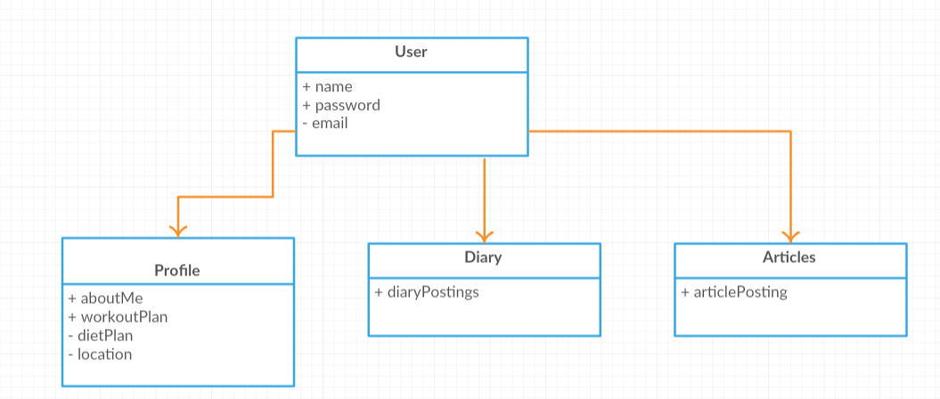

Within the system, there will be four major attributes. Everyone will be considered a user, as their will be no need for an admin or admin rights since everyone will have the same capabilities. Of course, admin profiles and users can be created in the future if need be but all administrative work currently goes on in the background. All users will have a name, password and email attached to their profile. From the users, each person will have their own profile, diary, and articles page. Every user with a profile page will have 3 attributes which are an about me section, a workout plan section, and a location section. Every user with a diary will have 1 attribute which will have their diary postings created by that user. Every user with an articles page will have 1 attribute which is a page with article postings that are hyperlinks that you can click on to read accredited articles.

Data

The database will hold important information about a user such as their name, password and email. Users will have the ability to register an account which then gets added to the database. From the users, each person will have a profile which creates the profile table. Also, each user will have a diary which means there is a diary table where diaries are added to the database every time a new posting is created. There will also be an article posting table where articles are stored.

User Interface
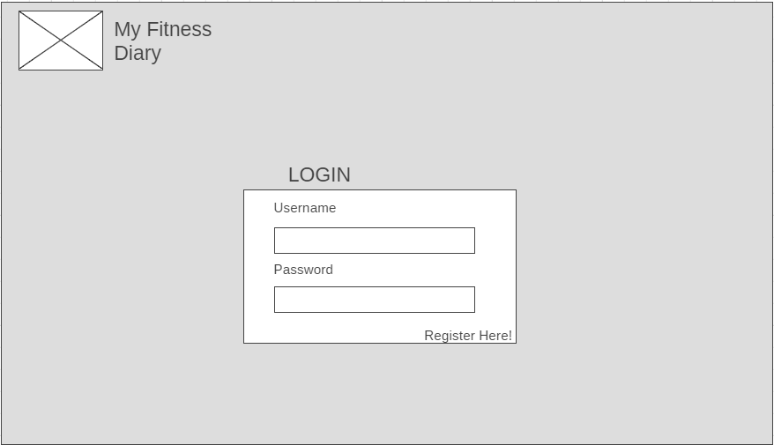

This will be the login page. Users will see a logo at the top, along with the name of the website. Then there is a spot to login, and a hyperlink to register a profile if the user does not already have a profile.

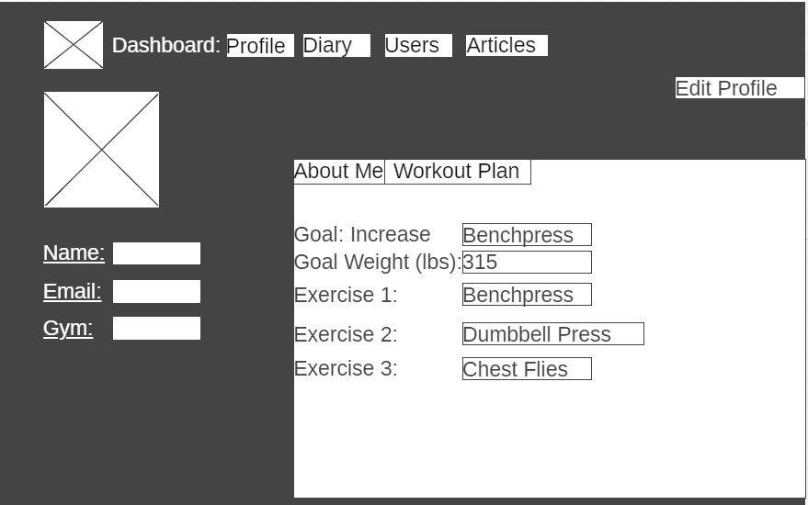

This is the profile page. There is a dashboard at the top of the page. There is a profile image location, as well as a small section where the user’s name is located, as well as their email and which gym they go to. There is an about me tab and workout plan tab. There is also an edit profile button.

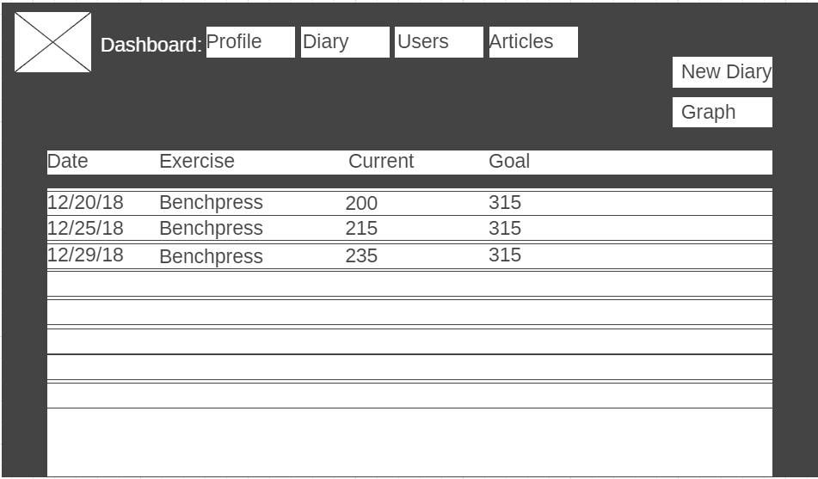

This is the diary page. The dashboard is located at the top. There is a button to create a new diary posting. Then there is a listing of all the diary postings. They are dated and it tells which exercise was done that day, as well as the current weight max and the goal. There is also a graph button which redirects to a page with a graph.

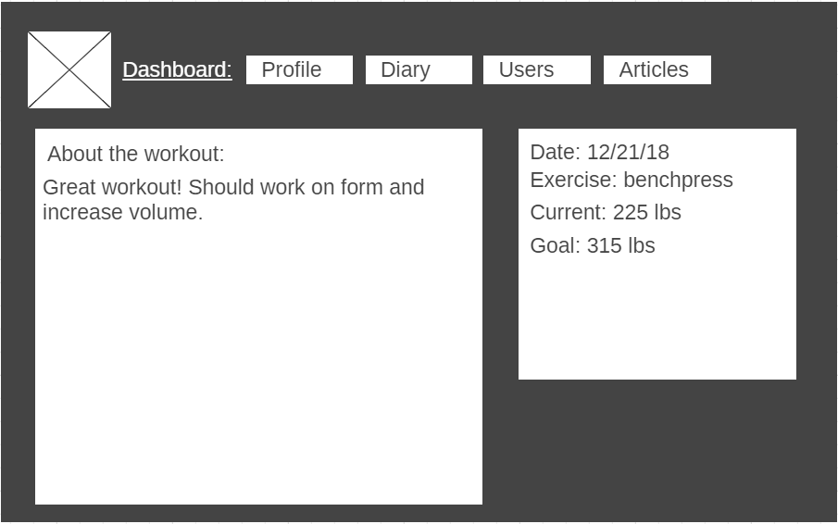

This is the diary posting. Once a diary posting is clicked on, there is an “about the workout” section. In this section, the user can write whatever they would like about the workout for that day, including keeping track of how the workout went and what they could or should do better next time. There is a small box to the right that has the details such as the date, exercise, current max, and goal weight.

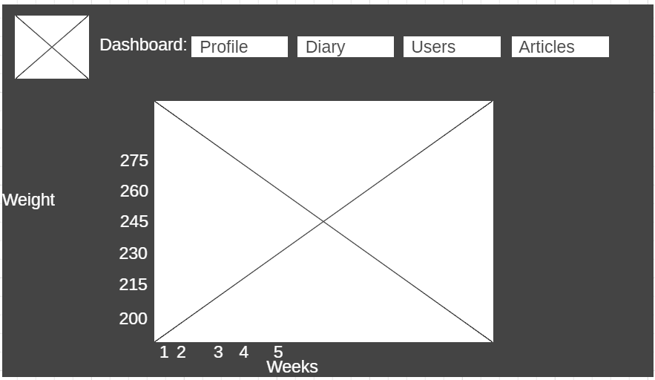

This is the graph section. On the diary page, there is a graph button. Once that graph button is pressed, you will be directed to this page where a graph is calculated based on the input you have provided. It will track your growth in weight for the specific exercise you are working on by week.

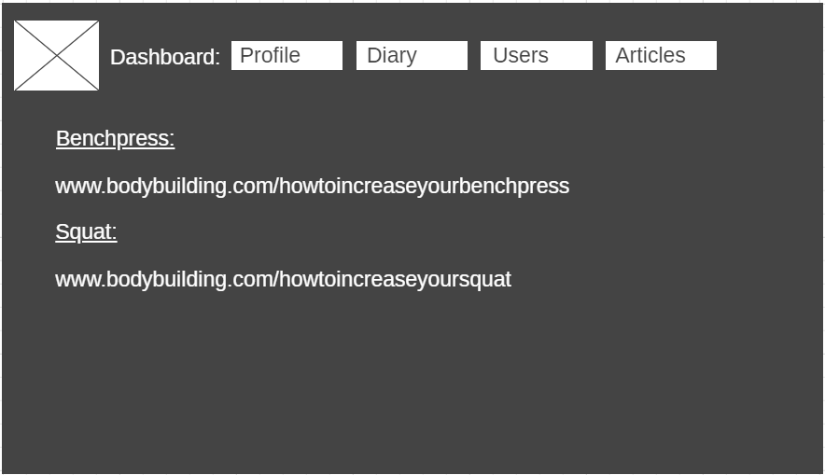

This is the articles page. There is the dashboard on top. There is also hyperlinks to useful articles and they will be split up and grouped based on the exercise.

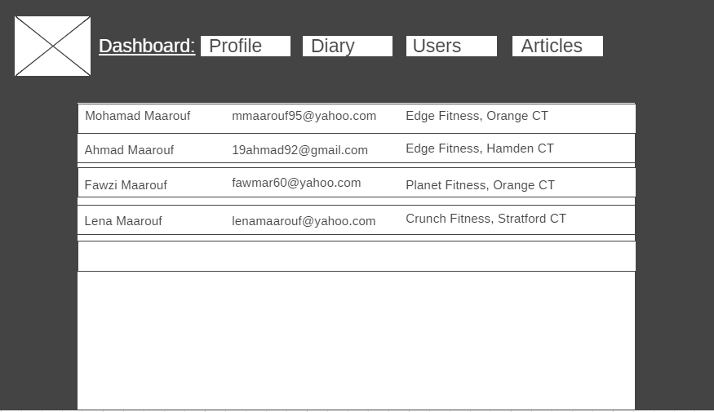

This is the other profiles section. Here, the user will see all the other users with profiles in the database. They see basic information such as name, email, and which gym they go to. They can then click on a user’s name to be redirected to that user’s profile page.

Gant Chart

